3.1 - Introduction to Azure virtual machines
Required resources for IaaS Virtual Machines
- The network
- VM name
- Location
- The VM size
- Disks
- Operating system

The network
- Virtual networks (VNets) are used in Azure to provide private connectivity between Azure Virtual Machines and other Azure services. VMs and services that are part of the same virtual network can access one another. By default, services outside the virtual network can't connect to services within the virtual network. You can, however, configure the network to allow access to the external service, including your on-premises servers.
- This latter point is why you should spend some time thinking about your network configuration. Network addresses and subnets aren't trivial to change once you have them set up. If you plan to connect your private company network to the Azure services, you want to make sure you consider the topology before putting any VMs into place.
- By default, there's no security boundary between subnets, so services in each of these subnets can talk to one another. However, you can set up Network Security Groups (NSGs), which allow you to control the traffic flow to and from subnets and to and from VMs. NSGs act as software firewalls, applying custom rules to each inbound or outbound request at the network interface and subnet level. This way, you can fully control every network request coming in or out of the VM.

Azure reserves the first four addresses and the last address in each subnet for its use.

Plan each VM deployment
Once you have mapped out your communication and network requirements, you can start thinking about the VMs you want to create. A good plan is to select a server and take an inventory:
- Which OS is used?
- How much disk space is in use?
- What kind of data does this use? Are there restrictions (legal or otherwise) around how it's stored or where it's physically located?
- What sort of CPU, memory, and disk I/O load does the server have? Is there burst traffic to account for?

VM name
The VM name is used as the computer name, which is configured as part of the operating system. You can specify a name of up to 64 characters on a Linux VM and 15 characters on a Windows VM.
This name also defines a manageable Azure resource, and it's not trivial to change later. That means you should choose names that are meaningful and consistent, so you can easily identify what the VM does.
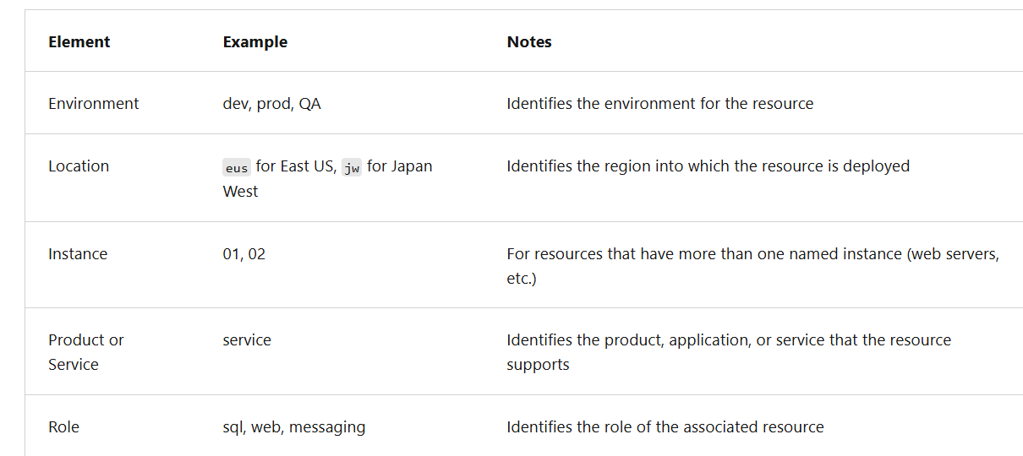

Decide the location for the VM
- Azure has datacenters all over the world filled with servers and disks. These datacenters are grouped into geographic regions ('West US', 'North Europe', 'Southeast Asia', etc.) to provide redundancy and availability.
- When you create and deploy a virtual machine, you must select a region where you want to allocate the resources. You can place your VMs as close as possible to your users to improve performance and to meet any legal, compliance, or tax requirements.
- Two other things to think about regarding the location choice. First, the location can limit your available options. Each region has different hardware available and some configurations aren't available in all regions. Second, there are price differences between locations. If your workload isn't bound to a specific location, it can be very cost effective to check your required configuration in multiple regions to find the lowest price.
Determine the size of the VM
- Once you have the name and location set, you need to decide on the size of your VM. Rather than specify processing power, memory, and storage capacity independently, Azure provides different VM sizes that offer variations of these elements in different sizes. Azure provides a wide range of VM size options allowing you to select the appropriate mix of compute, memory, and storage for what you want to do.
- The best way to determine the appropriate VM size is to consider the type of workload your VM needs to run. Based on the workload, you're able to choose from a subset of available VM sizes.
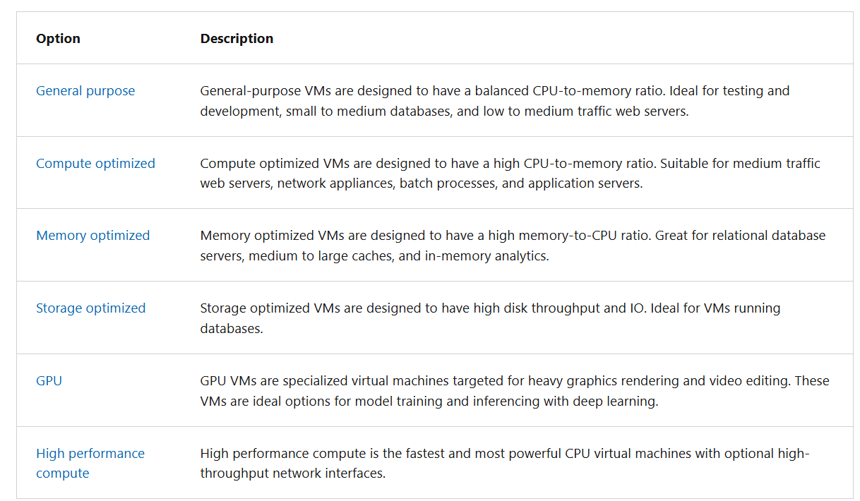

What if my size needs change?
- Azure allows you to change the VM size when the existing size no longer meets your needs. You can upgrade or downgrade the VM, as long as your current hardware configuration is allowed in the new size. The ability to change VM size provides a fully agile and scalable approach to VM management.
- The VM size can be changed while the VM is running, as long as the new size is available in the current hardware cluster the VM is running on. The Azure portal makes the size options obvious by only showing you available size choices. The command line tools report an error if you attempt to resize a VM to an unavailable size. Changing a running VM size automatically reboots the machine to complete the request.
- If you stop and deallocate the VM, you can then select any size available in your region since deallocation removes your VM from the cluster it was running on.
- Be careful about resizing production VMs - they will be rebooted automatically which can cause a temporary outage and change some configuration settings such as the IP address.
Parts of a VM and how they're billed
When you create a virtual machine, you're also creating resources that support the virtual machine. These resources come with their own costs that should be considered.
Understanding the pricing model
There are two separate costs the subscription is charged for every VM: compute and storage. By separating these costs, you scale them independently and only pay for what you need.
Compute costs - Compute expenses are priced on a per-hour basis but billed on a per-minute basis. For example, you're only charged for 55 minutes of usage if the VM is deployed for 55 minutes. You're not charged for compute capacity if you stop and deallocate the VM since deallocation releases the hardware. The hourly price varies based on the VM size and OS you select. Linux-based instances are cheaper because there's no operating system license charge. For Windows, the cost for a VM includes the charge for the operating system.
Storage costs - You're charged separately for the storage the VM uses. The status of the VM has no relation to the storage charges that are incurred. If the VM is stopped/deallocated and you aren’t billed for the running VM, you're still charged for the storage used by the disks.

Storage for the VM
All Azure virtual machines have at least two virtual hard disks (VHDs). The first disk stores the operating system, and the second is used as temporary storage. You should add more data disks to store application data. Separating out the data to different disks allows you to manage the disks independently. The VM size determines the maximum number of data disks you can attach to your VM, typically two per vCPU.
There are five disk types, each intended to address a specific customer scenario:
- Ultra disks
- Premium SSD v2 (preview)
- Premium SSDs (solid-state drives)
- Standard SSDs
- Standard HDDs (hard disk drives)
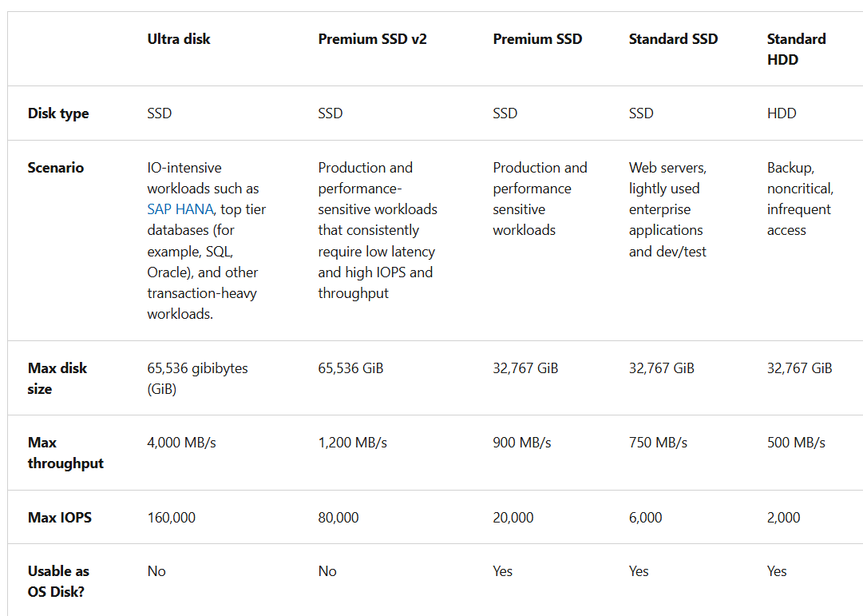

Select an operating system
Azure provides various OS images that you can install into the VM, including many Linux distributions. The choice of OS might influence your hourly compute pricing as Azure bundles the cost of the OS license into the price.
If you're looking for more than just base OS images, you can search the Azure Marketplace for more sophisticated images that include the OS and popular software tools for specific scenarios. For example, if you needed a new WordPress site, the standard technology stack would consist of a Linux server, Apache web server, a MySQL database, and PHP. Instead of setting up and configuring each component, you can use a Marketplace image and install the entire stack all at once.
Finally, if you can't find a suitable OS image, you can create your own image with what you need, and use them to create VMs. You can create individual images for use in development and test. Or, you can create an Azure Compute Gallery to manage multiple images and replicate them to the regions where they're needed.

What is availability?
Availability is the percentage of time a service is available for use.

Why do I need to think about availability when using Azure?
Azure VMs run on physical servers hosted within the Azure datacenter. As with most physical devices, there's a chance that there could be a failure. If the physical server fails, the virtual machines hosted on that server also fail. If a failure happens, Azure moves the VM to a healthy host server automatically. However, this self-healing migration could take several minutes, during which the application(s) hosted on that VM aren't available.
Periodic updates initiated by Azure itself can also affect the VMs. These maintenance events range from software updates to hardware upgrades and are required to improve platform reliability and performance. These events usually are performed without impacting any guest VMs, but sometimes the virtual machines reboot to complete an update or upgrade.

Availability zones
Availability zones expands the level of control you have to maintain the availability of the applications and data on your VMs. An Availability Zone is a physically separate zone, within an Azure region. There are three Availability Zones per supported Azure region.
Each Availability Zone has a distinct power source, network, and cooling. By designing your solutions to use replicated VMs in zones, you can protect your apps and data from the loss of a data center. If one zone is compromised, then replicated apps and data are instantly available in another zone.

Virtual Machines Scale Sets
Azure virtual machine scale sets let you create and manage a group of load balanced VMs. The number of VM instances can automatically increase or decrease in response to demand or a defined schedule. Scale sets provide high availability to your applications, and allow you to centrally manage, configure, and update many VMs. There's no cost for the scale set itself, you only pay for each VM instance that you create.
Virtual machines in a scale set can also be deployed into multiple availability zones, a single availability zone, or regionally. Availability zone deployment options may differ based on the orchestration mode.

Load balancer
Combine the Azure Load Balancer with an availability zone or availability set to get the most application resiliency. The Azure Load Balancer distributes traffic between multiple virtual machines. For our Standard tier virtual machines, the Azure Load Balancer is included. Not all virtual machine tiers include the Azure Load Balancer.

Azure Storage redundancy
Azure Storage always stores multiple copies of your data so that it's protected from planned and unplanned events, including transient hardware failures, network or power outages, and massive natural disasters. Redundancy ensures that your storage account meets its availability and durability targets even in the face of failures.
When deciding which redundancy option is best for your scenario, consider the tradeoffs between lower costs and higher availability. The factors that help determine which redundancy option you should choose include:
- How your data is replicated in the primary region
- Whether your data is replicated to a second region that is geographically distant to the primary region, to protect against regional disasters
- Whether your application requires read access to the replicated data in the secondary region if the primary region becomes unavailable for any reason

Failover across locations
You can also replicate your infrastructure across sites to handle regional failover. Azure Site Recovery replicates workloads from a primary site to a secondary location. If an outage happens at your primary site, you can fail over to a secondary location. This failover enables users to continue to access your applications without interruption. You can then fail back to the primary location after it's up and running again. Azure Site Recovery is about replication of virtual or physical machines; it keeps your workloads available in an outage.
While there are many attractive technical features to Site Recovery, there are at least two significant business advantages:
- Site Recovery enables the use of Azure as a destination for recovery, thus eliminating the cost and complexity of maintaining a secondary physical datacenter.
- Site Recovery makes it incredibly simple to test failovers for recovery drills without impacting production environments. This feature makes it easy to test your planned or unplanned failovers. After all, you don’t have a good disaster recovery plan if you’ve never tried to fail over.

Back up your virtual machines
Azure Backup is a backup as a service offering that protects physical or virtual machines no matter where they reside: on-premises or in the cloud.
Azure Backup can be used for a wide range of data backup scenarios, such as:
- Files and folders on Windows OS machines (physical or virtual, local or cloud)
- Application-aware snapshots (Volume Shadow Copy Service)
- Popular Microsoft server workloads such as Microsoft SQL Server, Microsoft SharePoint, and Microsoft Exchange
- Native support for Azure Virtual Machines, both Windows, and Linux
- Linux and Windows 10 client machines
Advantages of using Azure Backup
Traditional backup solutions don't always take full advantage of the underlying Azure platform. The result is a solution that tends to be expensive or inefficient. The solution either offers too much or too little storage, doesn't offer the correct types of storage, or has cumbersome and long-winded administrative tasks. Azure Backup was designed to work in tandem with other Azure services and provides several distinct benefits.
- Automatic storage management. Azure Backup automatically allocates and manages backup storage and uses a pay-as-you-use model. You only pay for what you use.
- Unlimited scaling. Azure Backup uses the power and scalability of Azure to deliver high availability.
- Multiple storage options. Azure Backup offers locally redundant storage where all copies of the data exist within the same region and geo-redundant storage where your data is replicated to a secondary region.
- Unlimited data transfer. Azure Backup doesn't limit the amount of inbound or outbound data you transfer. Azure Backup also doesn't charge for the data that is transferred.
- Data encryption. Data encryption allows for secure transmission and storage of your data in Azure.
- Application-consistent backup. An application-consistent backup means that a recovery point has all required data to restore the backup copy. Azure Backup provides application-consistent backups.
- Long-term retention. Azure doesn't limit the length of time you keep the backup data.

Use Azure Backup
Azure Backup uses several components that you download and deploy to each computer you want to back up. The component that you deploy depends on what you want to protect.
- Azure Backup agent
- System Center Data Protection Manager
- Azure Backup Server
- Azure Backup VM extension
Azure Backup uses a Recovery Services vault for storing the backup data. Azure Storage blobs back up a vault, making it an efficient and economical long-term storage medium. With the vault in place, you can select the machines to back up, and define a backup policy (when snapshots are taken and for how long they’re stored).

3.2 - Configure virtual machine availability
Plan for maintenance and downtime
Azure Administrators prepare for planned and unplanned failures.

Things to know about maintenance planning
An availability plan for Azure virtual machines needs to include strategies for unplanned hardware maintenance, unexpected downtime, and planned maintenance.
An unplanned hardware maintenance event occurs when the Azure platform predicts that the hardware or any platform component associated to a physical machine is about to fail. When the platform predicts a failure, it issues an unplanned hardware maintenance event. Azure uses Live Migration technology to migrate your virtual machines from the failing hardware to a healthy physical machine. Live Migration is a virtual machine preserving operation that only pauses the virtual machine for a short time, but performance might be reduced before or after the event.
Unexpected downtime occurs when the hardware or the physical infrastructure for your virtual machine fails unexpectedly. Unexpected downtime can include local network failures, local disk failures, or other rack level failures. When detected, the Azure platform automatically migrates (heals) your virtual machine to a healthy physical machine in the same datacenter. During the healing procedure, virtual machines experience downtime (reboot) and in some cases loss of the temporary drive.
Planned maintenance events are periodic updates made by Microsoft to the underlying Azure platform to improve overall reliability, performance, and security of the platform infrastructure that your virtual machines run on.

Microsoft doesn't automatically update your virtual machine operating system or other software. You have complete control and responsibility for those updates. However, the underlying software host and hardware are periodically patched to ensure reliability and high performance.

Create availability sets
An availability set is a logical feature you can use to ensure a group of related virtual machines are deployed together. The grouping helps to prevent a single point of failure from affecting all of your machines. The grouping ensures that not all of the machines are upgraded at the same time during a host operating system upgrade in the datacenter.
Things to know about availability sets
- Let's review some characteristics of availability sets.
- All virtual machines in an availability set should perform the identical set of functionalities.
- All virtual machines in an availability set should have the same software installed.
- Azure ensures that virtual machines in an availability set run across multiple physical servers, compute racks, storage units, and network switches.
- If a hardware or Azure software failure occurs, only a subset of the virtual machines in the availability set are affected. Your application stays up and continues to be available to your customers.
- You can create a virtual machine and an availability set at the same time.
- A virtual machine can only be added to an availability set when the virtual machine is created. To change the availability set for a virtual machine, you need to delete and then recreate the virtual machine.
- You can build availability sets by using the Azure portal, Azure Resource Manager (ARM) templates, scripting, or API tools.
- Microsoft provides robust Service Level Agreements (SLAs) for Azure virtual machines and availability sets.

Adding your virtual machines to an availability set won't protect your applications from operating system or application-specific failures. You'll need to explore other disaster recovery and backup techniques to provide application-level protection.

Things to consider when using availability sets
- Availability sets are an essential capability when you want to build reliable cloud solutions. In your planning for availability sets, keep the following general principles in mind:
- Consider redundancy. To achieve redundancy in your configuration, place multiple virtual machines in an availability set.
- Consider separation of application tiers. Each application tier exercised in your configuration should be located in a separate availability set. The separation helps to mitigate single point of failure on all machines.
- Consider load balancing. For high availability and network performance, create a load-balanced availability set by using Azure Load Balancer. Load Balancer distributes incoming traffic across working instances of services that are defined in your load-balanced availability set.
- Consider managed disks. You can use Azure managed disks with your Azure virtual machines in availability sets for block-level storage.

Review update domains and fault domains
Azure Virtual Machine Availability Sets implements two node concepts to help Azure maintain high availability and fault tolerance when deploying and upgrading applications: update domains and fault domains. Each virtual machine in an availability set is placed in one update domain and one fault domain.

Things to know about update domains
An update domain is a group of nodes that are upgraded together during the process of a service upgrade (or roll out). An update domain allows Azure to perform incremental or rolling upgrades across a deployment. Here are some other characteristics of update domains.
- Each update domain contains a set of virtual machines and associated physical hardware that can be updated and rebooted at the same time.
- During planned maintenance, only one update domain is rebooted at a time.
- By default, there are five (non-user-configurable) update domains.
- You can configure up to 20 update domains.

Things to know about fault domains
A fault domain is a group of nodes that represent a physical unit of failure. Think of a fault domain as nodes that belong to the same physical rack.
- A fault domain defines a group of virtual machines that share a common set of hardware (or switches) that share a single point of failure. An example is a server rack serviced by a set of power or networking switches.
- Two fault domains work together to mitigate against hardware failures, network outages, power interruptions, or software updates.

Review availability zones
- Availability zones are a high-availability offering that protects your applications and data from datacenter failures. An availability zone in an Azure region is a combination of a fault domain and an update domain.
- Consider a scenario where you create three or more virtual machines across three zones in an Azure region. Your virtual machines are effectively distributed across three fault domains and three update domains. The Azure platform recognizes this distribution across update domains to make sure that virtual machines in different zones aren't updated at the same time.
- You can use availability zones to build high-availability into your application architecture by colocating your compute, storage, networking, and data resources within a zone and replicating in other zones.

Things to know about availability zones
Review the following characteristics of availability zones.
- Availability zones are unique physical locations within an Azure region.
- Each zone is made up of one or more datacenters that are equipped with independent power, cooling, and networking.
- To ensure resiliency, there's a minimum of three separate zones in all enabled regions.
- The physical separation of availability zones within a region protects applications and data from datacenter failures.
- Zone-redundant services replicate your applications and data across availability zones to protect against single-points-of-failure.
Things to consider when using availability zones
Azure services that support availability zones are divided into two categories.
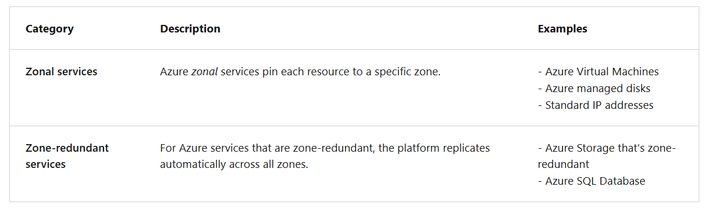

Compare vertical and horizontal scaling
A robust virtual machine configuration includes support for scalability. Scalability allows throughput for a virtual machine in proportion to the availability of the associated hardware resources. A scalable virtual machine can handle increases in requests without adversely affecting response time and throughput. For most scaling operations, there are two implementation options: vertical and horizontal.

Things to know about vertical scaling
Vertical scaling, also known as scale up and scale down, involves increasing or decreasing the virtual machine size in response to a workload. Vertical scaling makes a virtual machine more (scale up) or less (scale down) powerful.
Here are some scenarios where using vertical scaling can be advantageous:
- If you have a service built on a virtual machine that's under-utilized such as on the weekend, you can use vertical scaling to decrease the virtual machine size and reduce your monthly costs.
- You can implement vertical scaling to increase your virtual machine size to support larger demand without having to create extra virtual machines.
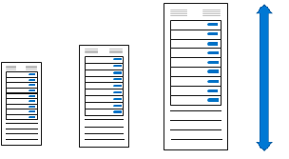
Things to know about horizontal scaling
Horizontal scaling, also referred to as scale out and scale in, is used to adjust the number of virtual machines in your configuration to support the changing workload. When you implement horizontal scaling, there's an increase (scale out) or decrease (scale in) in the number of virtual machine instances.
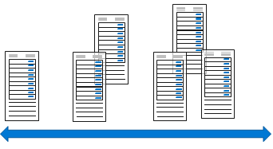

Things to consider when using vertical and horizontal scaling
Consider limitations. Generally speaking, horizontal scaling has fewer limitations than vertical scaling. A vertical scaling implementation depends on the availability of larger hardware, which quickly hits an upper limit and can vary by region. Vertical scaling also usually requires a virtual machine to stop and restart, which can temporarily limit access to applications or data.
Consider flexibility. When operating in the cloud, horizontal scaling is more flexible. A horizontal scaling implementation allows you to run potentially thousands of virtual machines to manage changes in workload and throughput.
Consider reprovisioning. Reprovisioning is the process of removing an existing virtual machine and replacing it with a new machine. A robust availability plan considers where reprovisioning might be required and plans for interruptions to service. If reprovisioning might be required, determine if any data needs to be maintained and migrated to the new machine.

Implement Azure Virtual Machine Scale Sets
- Azure Virtual Machine Scale Sets are an Azure Compute resource that you can use to deploy and manage a set of identical virtual machines. When you implement Virtual Machine Scale Sets and configure all your virtual machines in the same way, you gain true autoscaling. Virtual Machine Scale Sets automatically increases the number of your virtual machine instances as application demand increases, and reduces the number of machine instances as demand decreases.
- With Virtual Machine Scale Sets, you don't need to pre-provision your virtual machines. It's easier to build large-scale services that target large compute, big data, and containerized workloads. As workloads increase, more virtual machine instances can be added. As workloads decrease, virtual machines instances can be removed. The process of adding and removing machines can be manual or automated, or a combination of both.

Things to know about Azure Virtual Machine Scale Sets
Review the following characteristics of Azure Virtual Machine Scale Sets.
- All virtual machine instances are created from the same base operating system image and configuration. This approach lets you easily manage hundreds of virtual machines without extra configuration tasks or network management.
- Virtual Machine Scale Sets support the use of Azure Load Balancer for basic layer-4 traffic distribution, and Azure Application Gateway for more advanced layer-7 traffic distribution and TLS/SSL termination.
- You can use Virtual Machine Scale Sets to run multiple instances of your application. If one of the virtual machine instances has a problem, customers continue to access your application through another virtual machine instance with minimal interruption.
- Customer demand for your application might change throughout the day or week. To meet customer demand, Virtual Machine Scale Sets implements autoscaling to automatically increase and decrease the number of virtual machines.
- Virtual Machine Scale Sets support up to 1,000 virtual machine instances. If you create and upload your own custom virtual machine images, the limit is 600 virtual machine instances.

Implement autoscale
An Azure Virtual Machine Scale Sets implementation can automatically increase or decrease the number of virtual machine instances that run your application. This process is known as autoscaling. Autoscaling allows you to dynamically scale your configuration to meet changing workload demands.
Autoscaling minimizes the number of unnecessary virtual machine instances that run your application when demand is low. Your customers continue to receive an acceptable level of performance as demand grows and more virtual machine instances are automatically added.

Things to consider when using autoscaling
Review the following considerations about autoscaling. Think about how this process can benefit your company website implementation.
- Consider automatic adjusted capacity. You can create autoscaling rules to define the acceptable performance for a positive customer experience. When the defined thresholds are met, the autoscale rules act to adjust the capacity of your Virtual Machine Scale Sets implementation.
- Consider scale out. If your application demand increases, the load on the virtual machine instances in your implementation increases. If the increased load is consistent, rather than a brief demand, you can configure autoscale rules to increase the number of virtual machine instances in your implementation.
- Consider scale in. On an evening or weekend, your application demand might decrease. If the decreased load is consistent over a period of time, you can configure autoscale rules to decrease the number of virtual machine instances in your implementation. The scale-in action reduces the cost to run your Virtual Machine Scale Sets implementation as you only run the number of instances required to meet the current demand.
- Consider scheduled events. You can implement autoscaling and schedule events to automatically increase or decrease the capacity of your implementation at fixed times.
- Consider overhead. Using Azure Virtual Machine Scale Sets with autoscaling reduces your management overhead to monitor and optimize the performance of your application.

3.3 - Configure Azure App Service plans
Implement Azure App Service plans
In Azure App Service, an application runs in an Azure App Service plan. An App Service plan defines a set of compute resources for a web application to run. The compute resources are analogous to a server farm in conventional web hosting. One or more applications can be configured to run on the same computing resources (or in the same App Service plan).

Things to know about App Service plans
When you create an App Service plan in a region, a set of compute resources is created for the plan in the specified region. Any applications that you place into the plan run on the compute resources defined by the plan.
Each App Service plan defines these settings:
- Operating system: Linux or Windows.
- Region: The region for the App Service plan, such as West US, Central India, North Europe, and so on.
- Pricing tier: Determines what App Service features you get and how much you pay for the plan. The pricing tiers available to your App Service plan depend on the operating system selected at creation time.
- Number of VM instances: Currently ranges from three to 30.
- Size of VM instances: Defined by CPU, memory, and remote storage.
You can continue to add new applications to an existing plan as long as the plan has enough resources to handle the increasing load.

Things to consider when using App Service plans
Review the following considerations about using Azure App Service plans to run and scale your applications. Think about what conditions might apply to running and scaling the hotel website.
- Consider cost savings. Because you pay for the computing resources that your App Service plan allocates, you can potentially save money by placing multiple applications into the same App Service plan.
- Consider multiple applications in one plan. Create a single plan to support multiple applications, to make it easier to configure and maintain shared virtual machine instances. Because the applications share the same virtual machine instances, you need to carefully manage your plan resources and capacity.
- Consider plan capacity. Before you add a new application to an existing plan, determine the resource requirements for the new application and identify the remaining capacity of your plan.
- Consider application isolation. Isolate your application into a new App Service plan when:
  - The application is resource-intensive.
  - You want to scale the application independently from the other applications in the existing plan.
  - The application needs resource in a different geographical region.

Determine Azure App Service plan pricing
The pricing tier of an Azure App Service plan determines what App Service features you get and how much you pay for the plan. Pricing tier examples are: Free, Shared, Basic, Standard, Premium, PremiumV2, PremiumV3, Isolated, and IsolatedV2.

How applications run and scale in App Service plans
The Azure App Service plan is the scale unit of App Service applications. Depending on the pricing tier for your Azure App Service plan, your applications run and scale in a different manner. If your plan is configured to run five virtual machine instances, then all applications in the plan run on all five instances. If your plan is configured for autoscaling, then all applications in the plan are scaled out together based on the autoscale settings.
The pricing tiers are grouped into three categories:
- Shared compute:
  - Free and Shared, the two base tiers, run an app on the same Azure VM as other App Service apps, including apps of other customers.
  - These tiers allocate CPU quotas to each app that runs on the shared resources, and the resources can't scale out.
  - These tiers are intended to be used only for development and testing purposes.
- Dedicated compute:
  - The Basic, Standard, Premium, PremiumV2, and PremiumV3 tiers run apps on dedicated Azure VMs.
  - Only apps in the same App Service plan have the same compute resources. The higher the tier, the more VM instances that are available to you for scale-out.
- Isolated:
  - The Isolated and IsolatedV2 tiers run dedicated Azure VMs on dedicated Azure virtual networks.
  - This tier provides network isolation on top of compute isolation to your apps.
  - This tier provides the maximum scale-out capabilities.

Free and Shared service plans are base tiers that run on the same Azure virtual machines as other applications. Some applications might belong to other customers. These tiers are intended to be used for development and testing purposes only. No SLA is provided for the Free and Shared service plans. Free and Shared plans are metered on a per application basis.
Basic service plan is designed for applications that have lower traffic requirements, and don't need advanced auto scale and traffic management features. Pricing is based on the size and number of instances you run. Built-in network load-balancing support automatically distributes traffic across instances. The Basic service plan with Linux runtime environments supports Web App for Containers.
Standard service plan is designed for running production workloads. Pricing is based on the size and number of instances you run. Built-in network load-balancing support automatically distributes traffic across instances. The Standard plan includes auto scale that can automatically adjust the number of virtual machine instances running to match your traffic needs. The Standard service plan with Linux runtime environments supports Web App for Containers.
Premium service plan is designed to provide enhanced performance for production applications. The upgraded Premium plan, Premium v2, offers Dv2-series virtual machines with faster processors, SSD storage, and double memory-to-core ratio compared to the Standard tier. The new Premium plan also supports higher scale via increased instance count while still providing all the advanced capabilities of the Standard tier. The first generation of Premium plan is still available to support existing customer scaling needs.
Isolated service plan is designed to run mission critical workloads that are required to run in a virtual network. The Isolated plan allows customers to run their applications in a private, dedicated environment in an Azure datacenter. The plan offers Dv2-series virtual machines with faster processors, SSD storage, and a double memory-to-core ratio compared to the Standard tier. The private environment used with an Isolated plan is called the App Service Environment. The plan can scale to 100 instances with more available upon request.

Scale up and scale out Azure App Service
There are two methods for scaling your Azure App Service plan and applications: scale up and scale out. You can scale your applications manually or automatically, which is referred to as autoscale.

Things to know about Azure App Service scaling
Let's examine the details of scaling for your Azure App Service plan and App Service applications.
- The scale up method increases the amount of CPU, memory, and disk space. Scaling up gives you extra features like dedicated virtual machines, custom domains and certificates, staging slots, autoscaling, and more. You scale up by changing the pricing tier of the Azure App Service plan where your application is placed.
- The scale-out method increases the number of virtual machine instances that run your application. You can scale out to as many as 30 instances, depending on your App Service plan pricing tier. Take advantage of App Service Environments in the Isolated tier to further increase your scale-out count to 100 instances. The scale instance count can be configured manually or automatically (autoscale).
- With autoscale, you can automatically increase the scale instance count for the scale-out method. Autoscale is based on predefined rules and schedules.
- Your App Service plan can be scaled up and down at any time by changing the pricing tier of the plan.

Things to consider when using Azure App Service scaling
Review the following benefits of implementing scaling for your App Service plan and applications. Think about the scaling advantages for your hotel website.
- Consider manually adjusting plan tiers. Start your plan at a lower pricing tier and scale up as needed to acquire more App Service features. Scale down when features are no longer needed, and control your overall costs.
- Consider autoscale to support users and reduce costs. Keep serving your users when your application is experiencing high throughput. Implement autoscale to control how many features and support are offered at a given time based on your preference settings and rule conditions. Autoscale helps you save money when the load on your application decreases by automatically reducing your subscribed features.
- Consider no redeployment. When you change your scale settings, you don't need to change your code or redeploy your applications. Changing your plan scale settings takes only seconds to apply. Your changes affect all applications in your App Service plan.
- Consider scaling for other Azure services. If your App Service application depends on other Azure services, such as Azure SQL Database or Azure Storage, you can scale these resources separately. The App Service Plan doesn't manage these resources.

Configure Azure App Service autoscale
The autoscale process allows you to have the right amount of resources running to handle the load on your application. You can add resources to support increases in load and save money by removing idle resources.

Things to know about autoscale
Let's take a closer look at how to use autoscale for your Azure App Service plan and applications.
- To use autoscale, you specify the minimum, and maximum number of instances to run by using a set of rules and conditions.
- When your application runs under autoscale conditions, the number of virtual machine instances are automatically adjusted based on your rules. When rule conditions are met, one or more autoscale actions are triggered.
- An autoscale setting is used by the autoscale engine to determine whether to scale out or in. Autoscale settings are grouped into profiles.
- Autoscale rules include a trigger and a scale action (in or out). The trigger can be metric-based or time-based.
  - Metric-based rules measure application load and add or remove virtual machines based on the load, such as "do this action when CPU usage is above 50%." Example metrics include CPU time, Average response time, and Requests.
  - Time-based rules (or, schedule-based) allow you to scale when you see time patterns in your load and want to scale before a possible load increase or decrease occurs. An example is "trigger a webhook every 8:00 AM on Saturday in a given time zone."
- The autoscale engine uses notification settings.
  - A notification setting defines what notifications should occur when an autoscale event occurs based on satisfying the criteria of an autoscale setting profile. Autoscale can notify one or more email addresses or make calls to one or more webhooks.

Things to consider when configuring autoscale
There are several considerations to keep in mind when you configure autoscale for your Azure App Service plan and applications.
- Minimum instance count. Set a minimum instance count to make sure your application is always running even when there's no load.
- Maximum instance count. Set a maximum instance count to limit your total possible hourly cost.
- Adequate scale margin. Make sure your maximum and minimum instance count values are different, and set an adequate margin between the two values. You can automatically scale between the minimum and maximum by using rules you create.
- Scale rule combinations. Always use a scale-out and scale-in rule combination that performs an increase and decrease. If you don't set a scale-out rule, your application might fail, or performance might degrade under increased loads. If you don't set a scale-in rule, you can experience unnecessary and extensive costs when the load decreases.
- Metric statistics. Carefully choose the appropriate statistic for your diagnostic metrics, including Average, Minimum, Maximum, and Total.
- Default instance count. Always select a safe default instance count. The default instance count is important because autoscale scales your service to the count you specify when metrics aren't available.
- Notifications. Always configure autoscale notifications. It's important to maintain awareness of how your application is performing as the load changes.

3.4 - Configure Azure App Service
Implement Azure App Service
Azure App Service brings together everything you need to create websites, mobile backends, and web APIs for any platform or device. Applications run and scale with ease in both Windows and Linux-based environments.
App Service provides Quickstarts for programming languages. These languages include: ASP.NET, Java, Node.js, Python, and PHP.

App Service benefits
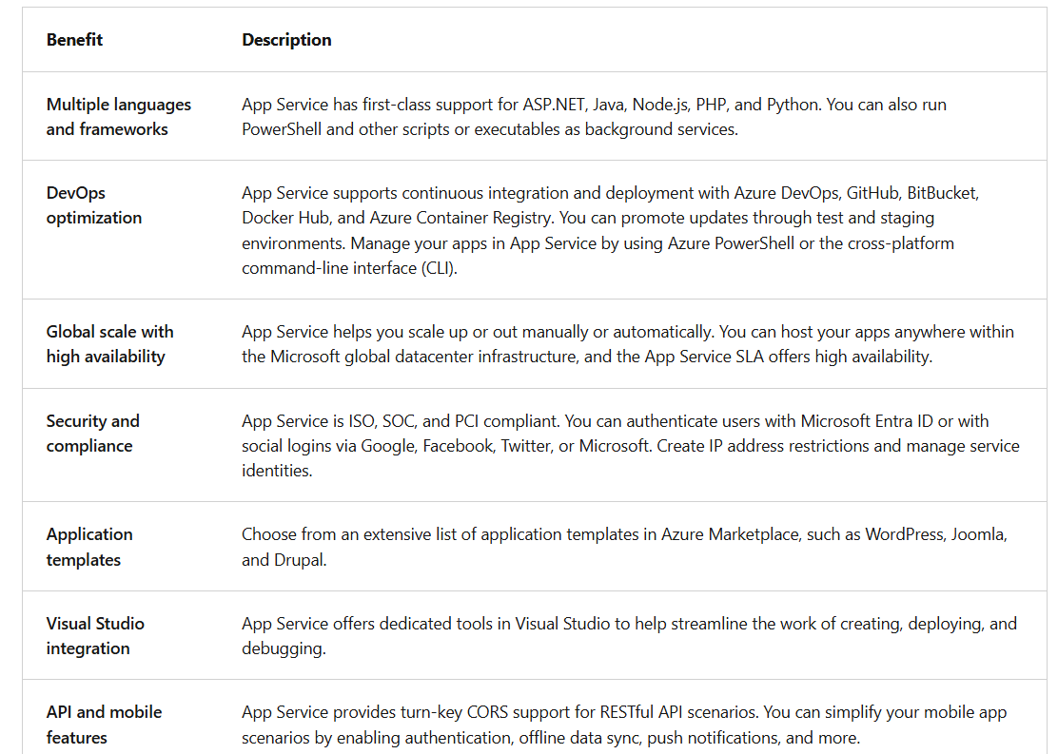

Create an app with App Service
You can use the Web Apps, Mobile Apps, or API Apps features of Azure App Service, and create your own apps in the Azure portal.

Things to know about configuration settings
Let's examine some of the basic configuration settings you need to create an app with App Service.
- Name: The name for your app must be unique. The name identifies and locates your app in Azure. An example name is webappces1.azurewebsites.net. You can map a custom domain name, if you prefer to use that option instead.
- Publish: App Service hosts (publishes) your app as code or as a Docker Container.
- Runtime stack: App Service uses a software stack to run your app, including the language and SDK versions. For Linux apps and custom container apps, you can set an optional start-up command or file. Your choices for the stack include .NET Core, .NET Framework, Node.js, PHP, Python, and Ruby. Various versions of each product are available for Linux and Windows.
- Operating system: The operating system for your app runtime stack can be Linux or Windows.
- Region: The region location that you choose for your app affects the App Service plans that are available.
- Pricing plans: Your app needs to be associated with an Azure App Service plan to establish available resources, features, and capacity. You can choose from pricing tiers that are available for the region location you selected.

Post-creation settings
After your app is created, other Configuration settings become available in the Azure portal, including app deployment options and path mapping.
Some of the extra configuration settings can be included in the developer's code, while others can be configured in your app. Here are a few of the extra application settings.
- Always On: You can keep your app loaded even when there's no traffic. This setting is required for continuous WebJobs or for WebJobs that are triggered by using a CRON expression.
- Session affinity: In a multi-instance deployment, you can ensure your app client is routed to the same instance for the life of the session.
- HTTPS Only: When enabled, all HTTP traffic is redirected to HTTPS.

Explore continuous integration and deployment
The Azure portal provides out-of-the-box continuous integration and deployment with Azure DevOps services, GitHub, Bitbucket, FTP, or a local Git repository on your development machine. You can connect your web app with any of the above sources and App Service handles the rest for you. App Service autosynchronizes your code and any future changes to the code into your web app. With Azure DevOps services, you can also define your own build and release process. Compile your source code, run tests, and build and deploy the release into your web app every time you commit the code. All of the operations happen implicitly without any need for human administration.

Things to know about continuous and manual deployment
When you create your web app with App Service, you can choose continuous or manual deployment. As you review these options, consider which deployment method to implement for your App Service apps. These options are located in the Deployment Center.

Continuous deployment (CI/CD) is a process used to push out new features and bug fixes in a fast and repetitive pattern with minimal impact on end users. Azure supports automated deployment directly from several sources:
GitHub: Azure supports automated deployment directly from GitHub. When you connect your GitHub repository to Azure for automated deployment, any changes you push to your production branch on GitHub are automatically deployed for you.
Bitbucket: With its similarities to GitHub, you can configure an automated deployment with Bitbucket.
Local Git: The App Service Web Apps feature offers a local URL that you can add as a repository.
Azure Repos: Azure Repos is a set of version control tools that you can use to manage your code. Whether your software project is large or small, using version control as soon as possible is a good idea.

Manual deployment enables you to manually push your code to Azure. There are several options for manually pushing your code:
Remote Git: The App Service Web Apps feature offers a Git URL that you can add as a remote repository. Pushing to the remote repository deploys your app.
OneDrive: OneDrive is a service that lets you store and share files on the internet with a Microsoft account.
Dropbox: Dropbox is a file hosting service

Create deployment slots
When you deploy your web app, web app on Linux, mobile backend, or API app to Azure App Service, you can use a separate deployment slot instead of the default production slot.
Things to know about deployment slots
Let's take a closer look at the characteristics of deployment slots.
- Deployment slots are live apps that have their own hostnames.
- Deployment slots are available in the Standard, Premium, and Isolated App Service pricing tiers. Your app needs to be running in one of these tiers to use deployment slots.
- The Standard, Premium, and Isolated tiers offer different numbers of deployment slots.
- App content and configuration elements can be swapped between two deployment slots, including the production slot.
Things to consider when using deployment slots
There are several advantages to using deployment slots with your App Service app. Review the following benefits and think about how they can support your App Service implementation.
- Consider validation. You can validate changes to your app in a staging deployment slot before swapping the app changes with the content in the production slot.
- Consider reductions in downtime. Deploying an app to a slot first and swapping it into production ensures that all instances are ready. This option eliminates downtime when you deploy your app. The traffic redirection is seamless, and no requests are dropped because of swap operations. The entire workflow can be automated by configuring Auto swap when preswap validation isn't needed.
- Consider restoring to last known good site. After a swap, the slot with the previously staged app now has the previous production app. If the changes swapped into the production slot aren't as you expected, you can perform the same swap immediately to return to your "last known good site."
- Consider Auto swap. Auto swap streamlines Azure Pipeline scenarios where you want to deploy your app continuously with zero cold starts and zero downtime for app customers. When Auto swap is enabled from a slot into production, every time you push your code changes to that slot, App Service automatically swaps the app into production after it's warmed up in the source slot. Auto swap isn't currently supported for Web Apps on Linux.

Add deployment slots
Deployment slots are configured in the Azure portal. You can swap your app content and configuration elements between deployment slots, including the production slot.
Things to know about creating deployment slots
Let's review some details about how deployment slots are configured.
- New deployment slots can be empty or cloned.
- Deployment slot settings fall into three categories:
  - Slot-specific app settings and connection strings (if applicable).
  - Continuous deployment settings (when enabled).
  - Azure App Service authentication settings (when enabled).
- When you clone a configuration from another deployment slot, the cloned configuration is editable. Some configuration elements follow the content across the swap. Other slot-specific configuration elements stay in the source slot after the swap.
Swapped settings versus slot-specific settings
The following table lists settings that are swapped between deployment slots. The table also lists settings that remain in the source slot (slot-specific). As you review these settings, consider which features are required for your App Service apps.
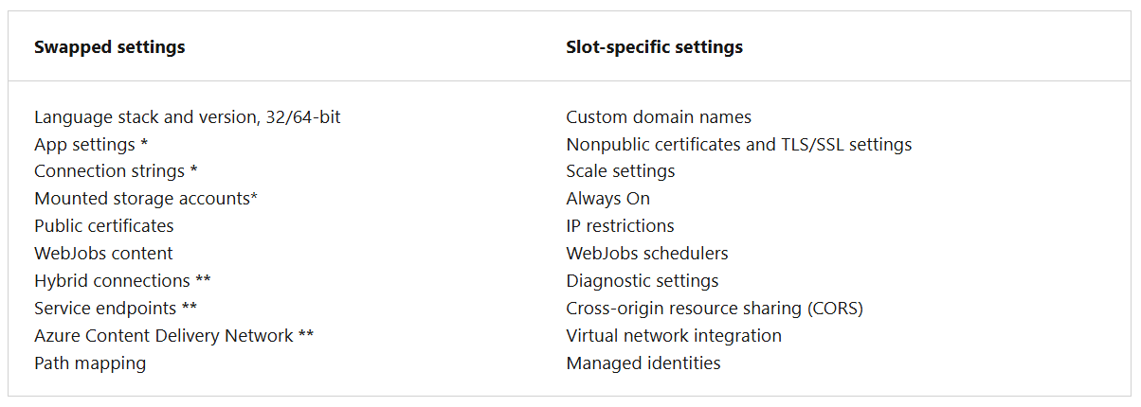
* Setting can be configured to be slot-specific.
** Feature isn't currently available.

Secure your App Service app
Azure App Service provides built-in authentication and authorization support. You can sign in users and access data by writing minimal or no code in your web app, API, and mobile backend, and also your Azure Functions apps.
Secure authentication and authorization require deep understanding of security, including federation, encryption, JSON web tokens (JWT) management, grant types, and so on. App Service provides these utilities so you can spend more time and energy on providing business value to your customer.

Things to know about app security with App Service
Let's take a closer look at how App Service helps you provide security for your app.
- The authentication and authorization security module in Azure App Service runs in the same environment as your application code, yet separately.
- The security module is configured by using app settings. No SDKs, specific languages, or changes to your application code are required.
- The security module handles several tasks for your app:
  - Authenticate users with the specified provider
  - Validate, store, and refresh tokens
  - Manage the authenticated session
  - Inject identity information into request headers

Things to consider when using App Service for app security
You configure authentication and authorization security in App Service by selecting features In the Azure portal. Review the following options and think about what security can benefit your App Service apps implementation.
- Allow Anonymous requests (no action). Defer authorization of unauthenticated traffic to your application code. For authenticated requests, App Service also passes along authentication information in the HTTP headers. This feature provides more flexibility for handling anonymous requests. With this feature, you can present multiple sign-in providers to your users.
- Allow only authenticated requests. Redirect all anonymous requests to /.auth/login/<provider> for the provider you choose. The feature is equivalent to Log in with <provider>. If the anonymous request comes from a native mobile app, the returned response is an HTTP 401 Unauthorized message. With this feature, you don't need to write any authentication code in your app.
- Logging and tracing. View authentication and authorization traces directly in your log files. If you see an authentication error that you didn’t expect, you can conveniently find all the details by looking in your existing application logs. If you enable failed request tracing, you can see exactly how the security module participated in a failed request. In the trace logs, look for references to a module named EasyAuthModule_32/64.

Create custom domain names
When you create a web app, Azure assigns the app to a subdomain of azurewebsites.net. Suppose your web app is named contoso. Azure creates a URL for your web app as contoso.azurewebsites.net. Azure also assigns a virtual IP address for your app. For a production web app, you might want users to see a custom domain name.
What is a custom domain?
A domain name is the address people type into a web browser to reach your website. A custom domain is a domain name that you own and configure to point to your Azure-hosted app, replacing the default Azure domain.
Using a custom domain allows you to:
- Establish a branded, user-friendly web address.
- Improve trust and credibility with customers.
- Manage and secure traffic to your application.

Steps to configure a custom domain name for your app
Creating a custom domain name requires providers, security, and naming information.
There are three steps to create a custom domain name.
- Reserve your domain name. The easiest way to set up a custom domain is to buy one directly in the Azure portal. (This name isn't the Azure assigned name of \*.azurewebsites.net.) The registration process enables you to manage your web app's domain name directly in the Azure portal instead of going to a third-party site. Configuring the domain name in your web app is also a simple process in the Azure portal.
- Create DNS records to map the domain to your Azure web app. The Domain Name System (DNS) uses data records to map domain names to IP addresses. There are several types of DNS records.
  - For web apps, you create either an A (Address) record or a CNAME (Canonical Name) record.
    - An A record maps a domain name to an IP address.
    - A CNAME record maps a domain name to another domain name. DNS uses the second name to look up the address. Users still see the first domain name in their browser. As an example, you could map contoso.com to your webapp.azurewebsites.net URL.
  - If the IP address changes, a CNAME entry is still valid, whereas an A record must be updated.
  - Some domain registrars don't allow CNAME records for the root domain or for wildcard domains. In such cases, you must use an A record.
- Enable the custom domain. After you have your domain and create your DNS record, use the Azure portal to validate your custom domain and add it to your web app. Be sure to test your domain before publishing.

To map a custom DNS name to your app, you need a paid tier of an App Service plan for your app.

Back up and restore your App Service app
The Backup and Restore feature in Azure App Service lets you easily create backups manually or on a schedule. You can configure the backups to be retained for a specific or indefinite amount of time. You can restore your app or site to a snapshot of a previous state by overwriting the existing content or restoring to another app or site.
The Backups page lists all the automatic and custom backups for your app and displays the status of each.
Things to know about Backup and Restore
Examine the following details about the Backup and Restore feature. Think about how you can implement this feature for your App Service apps.
- To use the Backup and Restore feature, you need the Standard or Premium tier App Service plan for your app or site.
- You need an Azure storage account and container in the same subscription as the app to back up.
- Azure App Service can back up the following information to the Azure storage account and container you configured for your app:
  - App configuration settings
  - File content
  - Any database connected to your app (SQL Database, Azure Database for MySQL, Azure Database for PostgreSQL, MySQL in-app)
- In your storage account, each backup consists of a Zip file and XML file:
  - The Zip file contains the back-up data for your app or site.
  - The XML file contains a manifest of the Zip file contents.
- You can configure backups manually or on a schedule.
- Full backups are the default.
- Partial backups are supported. You can specify files and folders to exclude from a backup.
- You restore partial backups of your app or site the same way you restore a regular backup.
- Backups can hold up to 10 GB of app and database content.
- Backups for your app or site are visible on the Containers page of your storage account and app (or site) in the Azure portal.

Things to consider when creating backups and restoring backups
Let's review some considerations about creating a backup for your app or site, and restoring data and content from a backup.
- Consider full backups. Do a full backup to easily save all configuration settings, all file content, and all database content connected with your app or site. When you restore a full backup, all content on the site is replaced with whatever is in the backup. If a file is on the site, but not in the backup, the file is deleted.
- Consider partial backups. Specify a partial backup so you can choose exactly which files to back up. When you restore a partial backup, any content located in an excluded folder or file is left as-is.
- Consider browsing back-up files. Unzip and browse the Zip and XML files associated with your backup to access your backups. This option lets you view the content without actually performing an app or site restore.
- Consider firewall on back-up destination. If your storage account is enabled with a firewall, you can't use the storage account as the destination for your backups.

Use Azure Application Insights
Azure Application Insights is a feature of Azure Monitor that lets you monitor your live applications. You can integrate Application Insights with your App Service configure to automatically detect performance anomalies in your apps.
Application Insights is designed to help you continuously improve the performance and usability of your apps. The feature offers powerful analytics tools to help you diagnose issues and understand what users actually do with your apps.
Things to know about Application Insights
- Let's examine some characteristics of Application Insights for Azure Monitor.
- Application Insights works on various platforms including .NET, Node.js, and Java EE.
- The feature can be used for configurations that are hosted on-premises, in a hybrid environment, or in any public cloud.
- Application Insights integrates with your Azure Pipeline processes, and has connection points to many development tools.
- You can monitor and analyze data from mobile apps by integrating with Visual Studio App Center.

Things to consider when using Application Insights
Application Insights is ideal for supporting your development team. The feature helps developers understand how your app is performing and how it's being used. Consider monitoring the following items in your App Service configuration scenario.
- Consider Request rates, response times, and failure rates. Find out which pages are most popular, at what times of day, and where your users are. See which pages perform best. If your response times and failure rates go high when there are more requests, then perhaps you have a resourcing problem.
- Consider Dependency rates, response times, and failure rates. Use Application Insights to discover if external services are degrading your app performance.
- Consider Exceptions. Analyze the aggregated statistics, or pick specific instances and drill into the stack trace and related requests. Both server and browser exceptions are reported.
- Consider Page views and load performance. Collect the number of page views reported by your users' browsers and analyze the load performance.
- Consider User and session counts. Application Insights can help you keep track of the number of users and sessions connected to your app.
- Consider Performance counters. Add Application Insights performance counters from your Windows or Linux server machines. Monitor performance output for the CPU, memory, network usage, and so on.
- Consider Host diagnostics. Integrate diagnostics from Docker or Azure into your app Application Insights.
- Consider Diagnostic trace logs. Implement trace logs from your app to help correlate trace events with requests and diagnose issues.
- Consider Custom events and metrics. Write your own custom events and metric tracking algorithms as client or server code. Track business events such as number of items sold, or number of games won.

3.5 - Configure Azure Container Instances
Compare containers to virtual machines
- Hardware virtualization makes it possible to run multiple isolated instances of operating systems concurrently on the same physical hardware. Containers represent the next stage in the virtualization of computing resources.
- Container-based virtualization allows you to virtualize the operating system. This approach lets you run multiple applications within the same instance of an operating system, while maintaining isolation between the applications. The containers within a virtual machine provide functionality similar to that of virtual machines within a physical server.

Things to know about containers versus virtual machines
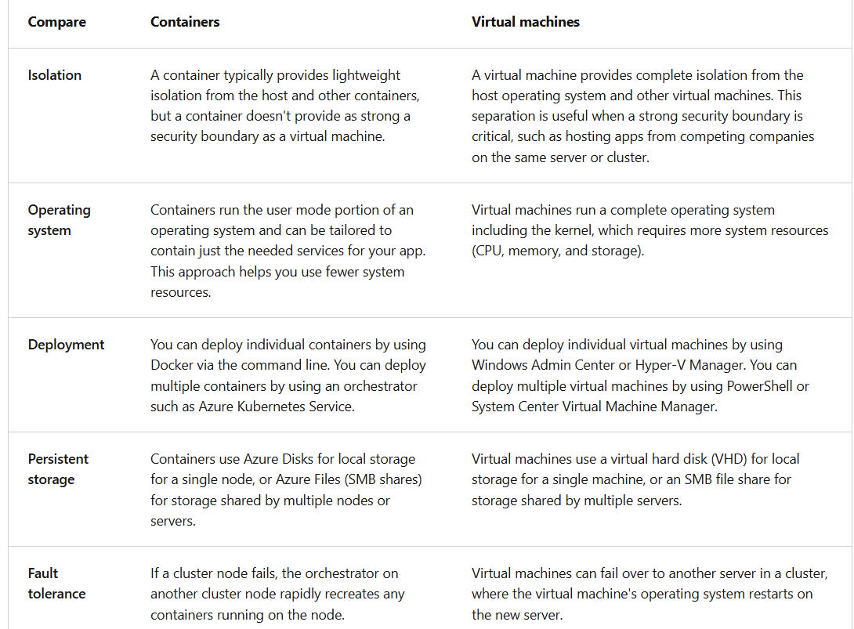

Things to consider when using containers
Containers offer several advantages over physical and virtual machines. Review the following benefits and consider how you can implement containers for the internal apps for your company.
- Consider flexibility and speed. Gain increased flexibility and speed when developing and sharing your containerized application code.
- Consider testing. Choose containers for your configuration to allow for simplified testing of your apps.
- Consider app deployment. Implement containers to gain streamlined and accelerated deployment of your apps.
- Consider workload density. Support higher workload density and improve your resource utilization by working with containers.

Review Azure Container Instances
Containers are becoming the preferred way to package, deploy, and manage cloud applications. There are many options for teams to build and deploy cloud native and containerized applications on Azure. In this unit, we review Azure Container Instances (ACI).
Azure Container Instances offers the fastest and simplest way to run a container in Azure, without having to manage any virtual machines and without having to adopt a higher-level service. Azure Container Instances is a great solution for any scenario that can operate in isolated containers.

Understand container images
All containers are created from container images. A container image is a lightweight, standalone, executable package of software that encapsulates everything needed to run an application. It includes the following components:
- Code: The application’s source code.
- Runtime: The environment required to execute the application.
- System tools: Utilities necessary for the application to function.
- System libraries: Shared libraries used by the application.
- Settings: Configuration parameters specific to the application.
When you create a container image, it becomes a portable unit that can run consistently across different computing environments. These images are the building blocks for containers, which are instances of these images running at runtime.
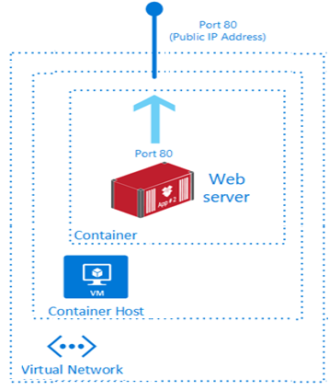
Things to know about Azure Container Instances
Let's review some of the benefits of using Azure Container Instances. As you review these points, think about how you can implement Container Instances for your internal applications.
- Fast startup times. Containers can start in seconds without the need to deploy and manage virtual machines.
- Public IP connectivity and DNS names. Containers can be directly exposed to the internet with an IP address and FQDN (fully qualified domain name).
- Custom sizes. Container nodes can be scaled dynamically to match actual resource demands for an application.
- Persistent storage. Containers support direct mounting of Azure Files file shares.
- Linux and Windows containers. Container Instances can schedule both Windows and Linux containers. Specify the operating system type when you create your container groups.
- Coscheduled groups. Container Instances supports scheduling of multi-container groups that share host machine resources.
- Virtual network deployment. Container Instances can be deployed into an Azure virtual network.

